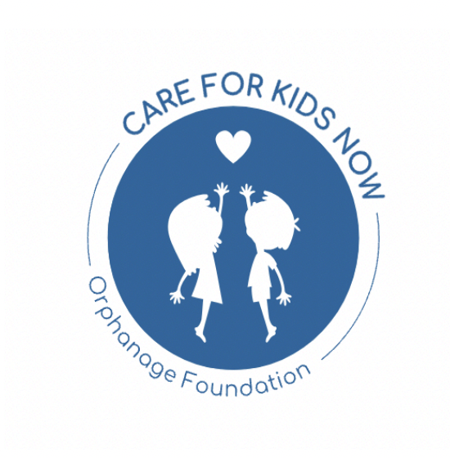
Stichting Care For Kids Now
Tweede Jacob van Campenstraat 11,
Amsterdam 1073 XN
Telephone: 020 671 3312
E-mail: info@careforkidsnow.org
RSIN: 863784343, KvK: 85912492
Annual Report of Expenditures: 19-06-2025 to 03-06-2026
Overview:
During the period from 19-06-2025 to 03-06-2026, Care for Kids Now continued its mission to support projects aimed at helping children and vulnerable individuals across different communities.
Below is a summary of the project expenditures recorded during this period. These transfers represent the project-related outgoing payments made by the foundation for the 2025-2026 reporting year.

Expenditures:
1. 11-07-2025: EUR 2,000.00
Purpose: Project transfer
Transaction ID: EM1107003575960
2. 14-07-2025: EUR 1,500.00
Purpose: Project transfer
Transaction ID: EM1307003579885
3. 01-10-2025: EUR 1,000.00
Purpose: Project transfer
Transaction ID: EM0110003767649
4. 25-11-2025: EUR 1,000.00
Purpose: Project transfer
Transaction ID: EM2511003896283
5. 10-12-2025: EUR 2,000.00
Purpose: Project transfer
Transaction ID: EM0912003935418
6. 02-02-2026: EUR 3,960.00
Purpose: Project transfer
Transaction ID: EM0202003062818
Total project expenditures for this reporting period: EUR 11,460.00
Key Projects:
The following project transfers have been recorded for the 2025-2026 reporting period:
• 11-07-2025: Project transfer - EUR 2,000.00
• 14-07-2025: Project transfer - EUR 1,500.00
• 01-10-2025: Project transfer - EUR 1,000.00
• 25-11-2025: Project transfer - EUR 1,000.00
• 10-12-2025: Project transfer - EUR 2,000.00
• 02-02-2026: Project transfer - EUR 3,960.00
Bank Charges Note:
Please note that ABN AMRO periodically charges the foundation EUR 24 in bank costs. As Care for Kids Now is a charity, these charges are occasionally refunded by the bank. Therefore, bank charges and refunds may appear in the bank statements but are not included as project expenditures.
Sincerely,
Guy Horowitz, founder & chairman

